Permitted Worker Permit

Important: This form can only be issued in accordance with Permitted Worker Permit Scheme Directions. If it is not issued in accordance with the Permitted Worker Permit Scheme Directions, it is invalid.

Individuals are not required to carry permits before 11.59pm Wednesday 5 August 2020.
Employer details |  | [“Employer”]
Company name | Transmetric Pty Ltd
ABN | 31 101 320 709
Company address | Suite 206, 89 High Street South, KEW 3101
Trading name  [If different to company name] | GEOCOUNTS Victoria
Permitted industry/activity | SECTOR: PUBLIC ADMINISTRATION AND SAFETY  - Public order, safety and Regulatory services  - Road and maritime services  Council Specific  - Emergency asset work that would impact substantially on the community or create a risk to the community if it is not undertaken  NB: we are reporting traffic conditions to VicRoads, VicPol, VicTrack and councils which is used to model economic activity and assist determine the impact of COVID control measures.

Employee details |  | [“Employee”]
Full name | Oleg Tartak
Date of birth
Residential address
Permitted Role for on-site work | Traffic counter installation and maintenance including on-call resolution of equipment safety issues (such as electrical or mechanical failure).

Employee work location [If different to company address]
Continuous traffic counters are installed all over Victoria – we maintain all of these.

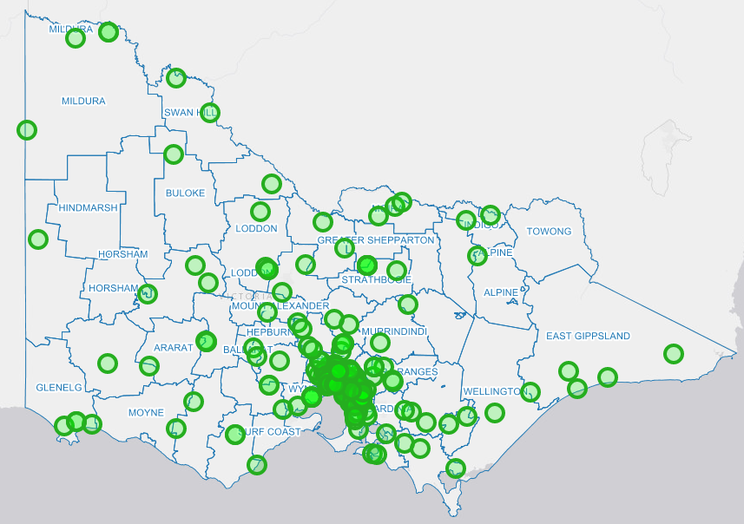

[If more than one, must be accompanied by a log recording each work location, and date and time of attendance]
Our log is stored in our company record keeping system “TUPI”. Here is a partial screen shot:

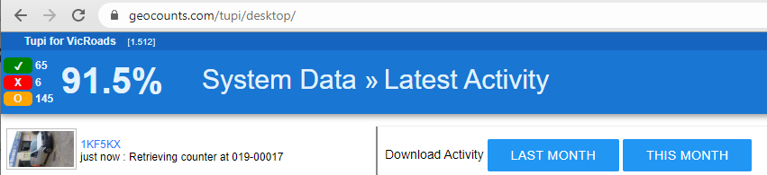

Signed
Employer |  |  | Employee
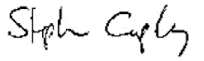  [Employer representative signature]  18 August, 2021  [Date]  By signing this permit, the Employer confirms compliance with the Permitted Worker Permit Scheme Directions, including:  - attests that the workplace is compliant with the directions of the Chief Health Officer and the Occupational Health and Safety Act 2004, all reasonable steps have been, and will continue to be taken, to maintain a safe working environment for the employee, and has a COVIDSafe plan in place;  - attests that the employer is a Permitted Employer engaged in providing a Permitted Service;  - attests that the information provided on this permit is a true representation relating to a current employee and their employment details;  - acknowledges that the nominated representatives may be contacted if deemed necessary to confirm these details; and  - acknowledges the information provided by the employer in the Permitted Worker Permit is true and correct, and that presenting false, misleading or fraudulent information may incur penalties. |  | [Employee signature]  18 August, 2021  [Date]  By signing this permit, the Employee:  - attests that their name, address, work hours, place of work, and employer, as contained in this Permitted Work Permit are true and correct that presenting false, misleading or fraudulent information may incur penalties;  - acknowledges that the nominated representatives may be contacted if deemed necessary to confirm these details and provides consent to the disclosure and collection of this information;  - understands the wording in this Permitted Work Permit relating to Diagnosed Persons and Close Contacts and agrees to not attend the Work Premises if either of these terms apply to the Employee's circumstances and will notify the Employer immediately if this occurs; and  - understands that if they develop symptoms or potential symptoms of COVID-19 they are not to attend or remain at the Work Premises and will immediately notify their employer.

Penalties
Completing this document with false or misleading information may cause you to be in breach of the Permitted Worker Permit Scheme Directions and liable to penalties up to $19,826.40 (individuals) and $99,132 (bodies corporate).

Hours of work
- Fill in either Table 1 or Table 2, as appropriate for the Employee’s working situation.
- Enter the Employee’s start and finish times for each day of the stage 4 restriction period.
- You do not need to include meal breaks or the total number of hours worked each day.
- Leave days blank or mark with an X when the Employee is not scheduled to work.
Table 1: Full-time employee (or working the same hours each week)
Rostered / scheduled work times
All weeks | Mon | Tue | Wed | Thu | Fri | Sat | Sun
[Example only] | 8.30–5.00 | 8.30–5.00 | 8.30–5.00 | X | 8.30–5.00 | X | X
1 Jan 2021 –  31 Dec 2021 | 7:30AM-8:30PM | 7:30AM-8:30PM | 7:30AM-8:30PM | 7:30AM-8:30PM | 7:30AM-8:30PM | 7:30AM-8:30PM  ON CALL | 7:30AM-8:30PM  ON CALL
NB: Times shown are available times but no employee works more than a total of 50 hours per week. Work is generated in response to government directions to install, remove or service a counter. In some cases, a member of the public could call Vic DOT or a council at any time to report a traffic counter malfunction and road tubes have been dislodged – we must be available to act.
All daily work plans are delivered to mobile phone and onboard computer. The field team always record their onsite activity – this is stored in the company record keeping system called “TUPI”.
Table 2: Part-time or casual employee (or working irregular hours each week)
Rostered / scheduled work times
Week | Commencing | Mon | Tue | Wed | Thu | Fri | Sat | Sun
[Example only] |  | 11.00–5.00 | X | 8.30–6.00 | 9.00–5.00 | 9.00–5.00 | 10.00–6.00 | X
1 | 16 Aug 2021
2 | 23 Aug 2021
3 | 30 Aug 2021
4 | 6 Sep 2021
5 | 13 Sep 2021
6 | 20 Sep 2021

Statement from the Employer
I declare that the Employer has taken all reasonable steps to avoid the necessity for the Employee to attend the Work Premises, but the Employer has determined that it is not reasonably practicable for the Employee to work from the premises at which the Employee ordinarily resides and the attendance of the Employee at the Work Premises is required for the provision of a Permitted Service of:
Traffic Counting - Equipment Installation and Maintenance
[Nominate industry or nature of work undertaken]

Issued by nominated representative of the Employer
Nominated representative |  | Secondary contact
Full name | Stephen Cropley | Full name | Karin Lin
Title / Role | Director | Title / Role | Director, Admin
Phone number | 0488 472 093 | Phone number | 0488 477 995

Also see a contact for VicRoads on attached work order

Diagnosed Persons and Close Contacts
If a person is a Diagnosed Person or Close Contact for the purposes of the Diagnosed Persons and Close Contacts Directions (No 8) that person cannot be provided with a Permitted Worker Permit or permitted to enter or remain upon work premises.
An employer who completes a Permitted Work Permit for a person who is a Diagnosed Person or Close Contact may be in breach of the Permitted Worker Permit Scheme Directions and liable to penalties.
If an Employee is displaying symptoms or potential symptoms of COVID-19, the Employee must not attend the Work Premises and must immediately notify the Employer of these symptoms.

